User Manual:

In order to use our program, run View.java which will launch the console based program.

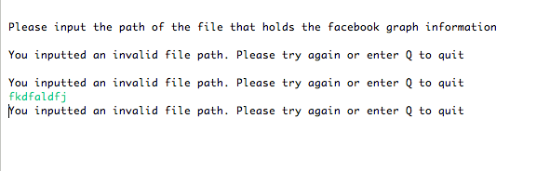

The first thing you will be prompted for is the input file path for the file that contains the facebook user information. The file contains a pair of space separated numbers that represents friendships amongst different users in the graph. You will be continually prompted until you enter a valid file path or enter Q to quit.

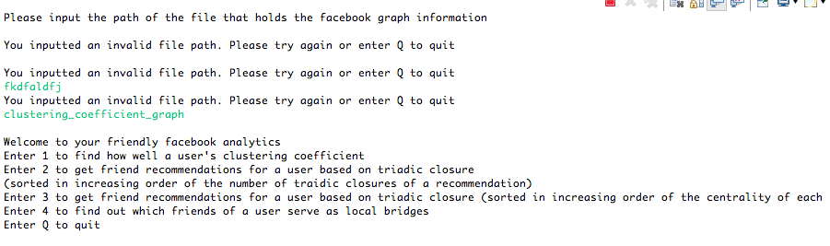
Once the file path has been entered, you will be prompted with the following options:

You can either enter 1, 2, 3, 4 or Q. Q will quit and terminate the program. If you enter either 1, 2, 3 or 4, you will be prompted to enter the user id of the user you want information about. Pressing 1 will print out the clustering coefficient for this user. Pressing 2 and 3 will both print out friend recommendations, both sorted in a particular way. Pressing 2 will consider all friends that fulfill triadic closures in the graph and print them out from the friend recommendation that will fulfill the least number of triadic closures to the one that will fulfill the most. Pressing 3 will instead organize recommendations in increasing order of betweeness centrality values of the recommendations. Pressing 4 will print out the friends of the inputted user id that are connected to the user via a local bridge.

